Title: **Unsealing/Sealing Circuit using Binaries** Job: 7.1

Course: Introduction to Automation Unit: Introduction of PLC CLO: 4

Name ____________________________ Station _______ Date ______________

**Objectives**

1. Student shall reinforce their knowledge of a sealing and unsealing control circuit.
2. Student shall develop a knowledge of PLC binary bits and their use.
3. Interpret how this circuit can be used in a motor control scenario.

**Assessment**

Students shall demonstrate a comprehension of the objectives listed above by scoring a minimum of 75% on this shop job. Grading shall be based on the Introduction to PLC rubric.

**Instructions**

Program the ladder logic shown below.

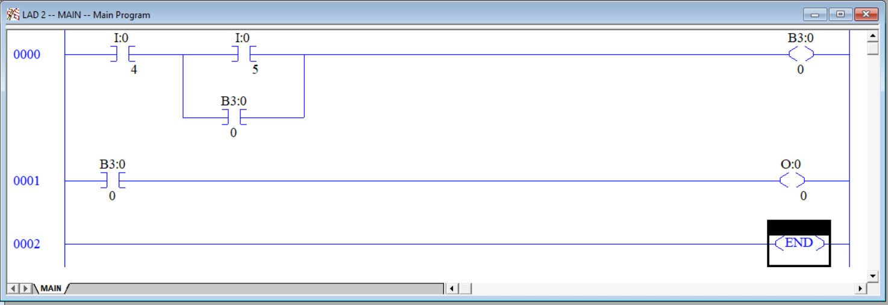

The input I:0/4 is the normally closed pushbutton (PB1) I:0/5 is the upper normally open pushbutton (PB2) and the output O:0/0 is the green pilot light. Notice that I:0/4 appears as a “normally open” set of contacts even though the actual pushbutton is wired “normally closed”. It is important to think of the normally open contact symbol in the PLC, actually termed *examine if closed* or *XIC*, as “test for a 1”. In the case of PB1, if I/4 input is a “1” (has 24VDC), it is permissible to energize the output. If the input is a “0” (has 0VDC), the output should not be energized. This is why an XIC instruction is used for PB1 in this circuit. B3:0/0 is an internal bit that only resides in memory. It is not tied to an input or an output (unless done so within the ladder logic). Another benefit of a PLC is the fact that it contains lots of memory that can be used to hold information other than that of an input or output. Note that 0001 is required for the operator to actually see any change. The state of B3:0/0 would not be known otherwise. Verify and download the program.

While watching RSLogix online perform the following tasks.

1. Press PB1 and note the behavior. _______________
2. Press PB2 and note the behavior. _______________
3. Press PB1 again and note the behavior. _______________

In the space below, design the addition of an ESTOP to this circuit.

|  |  |  |  |  |  |  |  |  |  |  |  |  |  |  |  |  |
| --- | --- | --- | --- | --- | --- | --- | --- | --- | --- | --- | --- | --- | --- | --- | --- | --- |
|  |  |  |  |  |  |  |  |  |  |  |  |  |  |  |  |  |
|  |  |  |  |  |  |  |  |  |  |  |  |  |  |  |  |  |
|  |  |  |  |  |  |  |  |  |  |  |  |  |  |  |  |  |
|  |  |  |  |  |  |  |  |  |  |  |  |  |  |  |  |  |
|  |  |  |  |  |  |  |  |  |  |  |  |  |  |  |  |  |
|  |  |  |  |  |  |  |  |  |  |  |  |  |  |  |  |  |
|  |  |  |  |  |  |  |  |  |  |  |  |  |  |  |  |  |
|  |  |  |  |  |  |  |  |  |  |  |  |  |  |  |  |  |
|  |  |  |  |  |  |  |  |  |  |  |  |  |  |  |  |  |
|  |  |  |  |  |  |  |  |  |  |  |  |  |  |  |  |  |
|  |  |  |  |  |  |  |  |  |  |  |  |  |  |  |  |  |
|  |  |  |  |  |  |  |  |  |  |  |  |  |  |  |  |  |
|  |  |  |  |  |  |  |  |  |  |  |  |  |  |  |  |  |
|  |  |  |  |  |  |  |  |  |  |  |  |  |  |  |  |  |
|  |  |  |  |  |  |  |  |  |  |  |  |  |  |  |  |  |
|  |  |  |  |  |  |  |  |  |  |  |  |  |  |  |  |  |
|  |  |  |  |  |  |  |  |  |  |  |  |  |  |  |  |  |

1. Discuss your design with the instructor. Instructor Initials _______
2. Compose, verify and download the new program.
3. Test program and ESTOP function.